Mire microclimate: groundwater buffers temperature in waterlogged versus dry soils

Eduardo Fernández-Pascual1 *, Eva Correia-Álvarez2

1 Universidad de Oviedo, 2 Independent researcher

* Correspondence: Departamento de Biología de Organismos y Sistemas, Universidad de Oviedo, C/ Catedrático Rodrigo Uría, 33006 Oviedo/Uviéu, Spain. Email: [efernandezpascual@gmail.com](mailto:efernandezpascual@gmail.com). Telephone: +34985104787.

# Graphical abstract

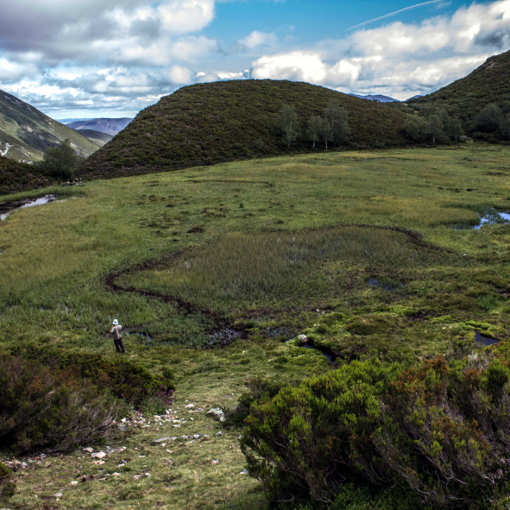

Mires are semi-terrestrial wetlands that remain waterlogged for most of the year. Mire groundwater produces a thermal buffer effect that insulates these habitats from the surrounding landscape, especially at the warm end of the climatic spectrum, i.e. during summer and at lower elevations. This highlights the potential refugial character of mires from global warming, and the need to integrate in situ microclimate measurements into climate change models.